Unit 2 WireFrame & SiteMap

Sidnee Hamilton

Internet Foundations

Dr. Helen Schleckser

January 21, 2024

Home

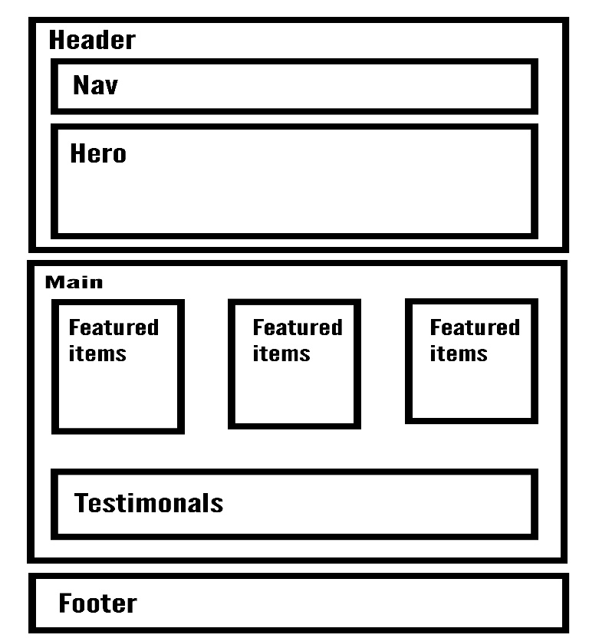

View Cart

Check Out

Contact Us

About Us

Shop Now